LibraTech: Extending Occupancy Detection with a Privacy-First, Student-Centric Service Hub

Base Paper Title: "A Novel Approach to Library Seat Occupancy Detection Using Deep Learning and Image Processing"

Full Citation:
"A Novel Approach to Library Seat Occupancy Detection Using Deep Learning and Image Processing,"arXiv:2306.16080.

Alternative Simplified Title for Reference:
"Deep Learning Based Library Seat Occupancy Detection"

The paper is available at: https://arxiv.org/abs/2306.16080

This is the foundational paper we used as the basis for creating the new research paper "LibraTech: Prioritizing Privacy and Practicality over Precision in Library Seat Detection" that compares computer vision approaches with our proposed user-driven QR code system.

Abstract

Abstract — Recent advances in computer vision, such as the Faster RCNN system proposed in [1], have shown remarkable precision in automating library seat occupancy detection. However, the deployment of continuous video surveillance in spaces dedicated to quiet study raises significant privacy, ethical, and practical concerns. This paper presents LibraTech, an alternative framework that questions the need for maximalist sensing. By employing a user-initiated QR code check-in system, we sacrifice a marginal degree of detection accuracy for massive gains in privacy and deployability. Furthermore, we extend this framework beyond simple seat finding to include a holistic suite of student services, such as group study filters and an integrated digital textbook hub. In a pilot study of the core occupancy features, LibraTech achieved 92% operational accuracy, while user surveys indicated a 95% preference for our privacy-preserving method. We conclude that for socitechnical systems, optimizing for user well-being and practical utility is as important as optimizing for technical benchmarks.

1. Introduction

The chronic issue of seat scarcity in academic libraries is a universal pain point for students, leading to wasted time and increased stress. Automating seat occupancy detection has emerged as a key research area to address this problem. Recent work, such as the Faster RCNN-based deep learning system described by [1], demonstrates the powerful capabilities of computer vision in achieving high-precision, automated detection.

While these systems are technically impressive, they often fail the test of real-world deployment due to the ”big brother” effect and associated privacy costs. The installation of cameras in an environment designed for focused, private study creates an inherent conflict. This paper argues that for usercentric applications, a technically superior but invasive solution is often less desirable and less viable than a less precise but privacy-preserving alternative.

We propose LibraTech, a system that fundamentally rethinks this trade-off.

Our work makes the following key contributions:

- A novel, user-driven framework for seat occupancy detection that replaces invasive sensing with explicit, user-controlled check-ins via QR codes.

- A rigorous, multi-dimensional evaluation comparing our approach to a state-of-the-art vision-based system, considering not only accuracy but also privacy, cost, and social acceptance.

- A compelling argument that ”sufficient accuracy” achieved through a privacy-first design leads to greater real-world utility and deployability than ”maximum accuracy” achieved through surveillance.
- 2. Related Work

2.1 Vision-Based Occupancy Detection

The base paper[1]—which proposes a serial dual-channel Faster RCNN model trained on a hybrid of real and virtually-generated (UE5) data—and similar works [2, 3] utilize advanced object detection models to identify occupants from camera feeds. These methods report high accuracy (>95%) under controlled conditions but consistently grapple with challenges such as occlusions (e.g., by monitors or books) and complex lighting. More critically, their primary limitation lies in their pervasive surveillance model.

2.2 Privacy-Preserving Sensing

Alternative sensing methodologies aim to reduce privacy intrusion.These include the use of passive infrared (PIR) sensors [4], Wi-Fi probe request counting [5], and environmental sensor data. These methods infer occupancy without capturing identifiable visual data. Our work is positioned within this category, pushing the concept further by making the user an active, consenting participant in the data collection process.

2.3 HCI and Ethical Considerations

Research in Human-Computer Interaction(HCI) consistently shows that user acceptance is critical for the success of pervasive systems [6]. Studies on the ethics of surveillance in semi-public spaces highlight the chilling effects and discomfort caused by continuous monitoring [7]. LibraTech is designed with these principles at its core, prioritizing user agency and explicit consent.

3. The LibraTech Framework: A Privacy-First Approach

3.1 Design Philosophy

LibraTech is built on two core principles:”Sufficient Accuracy” and ”Participatory Sensing.” We posit that for the application of seat finding, a system that is 90-95% accurate is functionally equivalent to a 96%+ accurate system from a user’s perspective, provided the former offers superior privacy and ease of use. Participatory sensing empowers users, transforming them from passive subjects of surveillance into active contributors to a community resource.

3.2 The LibraTech+ Solution: A Student-Centric Service Hub

The LibraTech architecture moves beyond the complex pipeline of vision-based systems (Camera -> Model -> Server) to a community-powered, service-oriented model. It is a mobile application built on simple, low-cost technology. The solution’s key features include:

- Live Interactive Map: A real-time map of the library’s layout where each seat is a dot (Green for Available, Red for Occupied). A top-level counter shows total free seats, allowing students to check availability before walking
to the library.

- Smart Check-In/Check-Out: The system’s ”magic.” Users scan a QR code at the entrance to check in and are guided to an available seat. When leaving, they press a ”Check Out” button. This user-driven action keeps the map accurate for the entire community.

- Group Study Filter: A filter to find and display only areas where a required number of seats (e.g., 2, 4, or 6) are available together, solving a major pain point for study groups.

- Digital Textbook Hub: Extending the app’s utility beyond the physical space, this feature provides a searchable, centralized directory of all digital course materials, with direct links to the library’s e-books and online resources, organized by course code.

The technical complexity is shifted from invasive sensing algorithms to a robust, user-friendly, and high-value mobile application.

- Experimental Evaluation: A Multi-Dimensional Comparison

4.1 Methodology

We deployed a pilot of the LibraTech system in a designated section of a university library over a two-week period,including exam season.

- Baseline: We used the reported results from the vision-based base paper [1] as a benchmark for technical accuracy. For our own system, we conducted periodic manual headcounts to establish a ground truth for accuracy calculation.

- Metrics: Our evaluation extended beyond a single technical metric to in-

clude: Technical Performance: Occupancy Detection Accuracy. Human

Centric Factors: User Preference and Perceived Privacy (measured via a

Likert-scale survey), and Willingness-to-Use. Practicality: Estimated Deployment Cost and Implementation Complexity.

4.2 Results and Comparative Analysis

The results of our pilot study and the subsequent comparative analysis are summarized below.

Quantitative & Qualitative Results:

- LibraTech achieved an average operational accuracy of 92% in determining seat availability during peak hours, compared to the 96% reported by [1].

- In a survey of 50 students, 95% indicated they would refuse to use a library equipped with camera-based occupancy tracking.

- Conversely, 88% of respondents expressed a willingness to use LibraTech, citing privacy and control as key reasons.
Comparative Analysis Table:

Evaluation Dimension | Vision-Based System [1] (Faster RCNN) | LibraTech(Our
Detection Accuracy | High (~96%) | Sufficiently High (
User Privacy | Very Low (Continuous Video) | Very High (User-Co
Social Acceptance | Very Low | Very High
Deployment Cost | High (Cameras, GPUs, Networking) | Low (QR codes, ap
Implementation Complexity | High (CV Model Training/Setup) | Low (Web Stack, D
Handles Occlusions? | No (Acknowledged weakness) | Yes (Inherently)
Real-World Deployability | Low (Significant Ethical Hurdles) | High (Immediately

5. Discussion

The data clearly demonstrates a compelling trade-off. The 4% deficit in technical accuracy is negligible when weighed against the monumental gains in user privacy, social acceptance, and cost-effectiveness. LibraTech’s ”human-in-the-loop” design inherently solves problems that plague automated systems; for instance, the issue of a seat being ”occupied” by a bag is resolved by relying on the user’s own declaration of presence or departure.

We must also address the limitations of our approach. LibraTech relies on user compliance; a user may forget to check out, creating a ”ghost occupancy.” Future work will explore gentle notification nudges and timeout mechanisms to mitigate this. Furthermore, initial user adoption is a hurdle, though the clear and immediate benefit the app provides serves as a strong incentive.

6. Conclusion and Future Work

This paper presented LibraTech, a privacy-first framework for library management. We argued that in human-centered computing environments, optimizing for sociotechnical factors like privacy and acceptance is not merely an option but a necessity for viable deployment. By challenging the paradigm that prioritizes precision above all else, we have demonstrated a practical, ethical, and effective alternative to invasive sensing.

Future work will focus on enhancing the robustness of our core occupancy system. We also plan to expand the service-hub concept, integrating our user-reported data with non-invasive sensors (as in [4]) to enrich longitudinal analytics for library administration, all without compromising the core privacy principles of the system. By combining physical space management (seat-finding) with digital resource access (the textbook hub), LibraTech provides a holistic and in-dispensable tool for student life.

Algorithms

. Live Occupancy Counter
Purpose: To display the number of students currently in the library and the number of available seats.
Algorithm Steps:
- Fetch Total Seats: The system first queries the database to get the total seating capacity for a specific library.
- Count Occupied Seats: It then counts the number of users who are currently checked into a seat in that same library.
- Calculate Availability: The system subtracts the number of occupied seats from the total number of seats to find the number of available seats.
- Return Data: Finally, it returns both the occupied and available seat counts to be displayed to the user.

2. Interactive Library Map
Purpose: To visually show the real-time status (available or occupied) of every seat on a map.
Algorithm Steps:
- Get All Seats: The system retrieves a complete list of all seats for a specific library, which includes each seat's ID and its (x, y) coordinates for the map.
- Initialize Map Data: An empty list is created to store the data for the map.
- Loop Through Seats: The system iterates through each seat one by one.
- Check Status: For each seat, it checks its is_available status.
- Assign Color:
  - If the seat is available, its status is set to "green".
  - If the seat is occupied, its status is set to "red".
- Build Map Data: The seat's ID, coordinates, and status color are added to the map data list.
- Return Data: The complete list of map data is returned, which is then used to render the visual map for the user.

3. Smart Check-In / Check-Out
Purpose: To update a seat's status instantly when a student occupies or leaves it.
Algorithm Steps (Check-In):
- Check Availability: When a user tries to check into a specific seat, the system first checks if that seat is currently marked as available.
- Handle Success: If the seat is available:
  - The seat's status is immediately updated to "occupied".
  - A log is created linking the user to that seat.
  - A broadcast_update is sent to all other users, notifying them that this seat is now occupied.
  - The system returns True to confirm the successful check-in.
- Handle Failure: If the seat is already occupied, the system returns False, and the check-in fails.
Algorithm Steps (Check-Out):
- Find User's Seat: When a user checks out, the system finds the seat currently associated with that user.
- Update Status: The seat is marked as "available" in the database.
- Log Event: The check-out is logged.
- Broadcast Update: A broadcast_update is sent to all other users, notifying them that this seat is now available.

4. Group Study Filter
Purpose: To find a cluster of adjacent (next-to-each-other) available seats for a group.
Algorithm Steps:
- Get Clusters: The system retrieves a list of all pre-computed seat clusters (groups of seats that are physically adjacent).
- Get Group Size: The user specifies the number of seats they need (e.g., group_size = 4).
- Iterate Clusters: The algorithm loops through each available cluster.
- Check Availability: For each cluster, it checks two conditions:
  - Are all seats within this cluster currently available?
  - Is the number of seats in this cluster greater than or equal to the user's desired group_size?
- Return Match: If both conditions are met, the algorithm takes the first group_size number of seats from that available cluster and returns them to the user.
- Return No Match: If no cluster meets the criteria after checking all of them, the system returns an empty list.

5. Digital Textbook Hub Search
Purpose: To allow users to search for and find course materials by subject or course code.
Algorithm Steps:
- Receive Query: The user enters a search term (e.g., "MATH101" or "Biology").
- Initialize Results: An empty list is created to store any matches.
- Loop Database: The algorithm iterates through every book in the textbook database.
- Check for Match: For each book, it checks if the user's query (converted to lowercase) exists in the book's title (lowercase) OR in the book's course code (lowercase).
- Add Match: If a match is found, the book is added to the results list.
- Return Results: After checking all books, the final list of matching results is returned to the user.
  - Note: This process is often optimized with a full-text search index to make it much faster for large databases.

6. Real-Time Sync Algorithm
Purpose: To ensure every user's device reflects the most current seat status instantly.
Algorithm Steps:
- Database Update: When a seat's status changes (e.g., a user checks in), the new status ("occupied") is first saved to the central database.
- Broadcast Notification: Immediately after the database is updated, the system uses a real-time technology (like a WebSocket or push notification) to send a message to all connected users.
- Deliver Update: This message contains the seat_id that changed and its new_status.
- Client-Side Update: Every user's app receives this message and instantly updates the map and counters on their screen without needing to refresh the page.

Data Flow Diagram

Level 0 DFD – Context Diagram
This diagram represents the system as a single unit interacting with external entities.
+------------------+ +------------------+ +---------------+
| | | | | | |
| Student User +-------->+ The App +<--------+ Library Admin| |
| | | | | | |
+------------------+ +------------------+ +---------------+
|
v
+------------------+
| Cloud Database |
+------------------+

Level 1 DFD – Major Components
This diagram shows the main subsystems of the app.
+------------------+ +------------------+ +---------------+
| | | | | | |
| Student User +-------->+ Mobile Interface+-------->+ Seat Tracker | |
| | | | | & QR System | |
+--------+---------+ +--------+---------+ +--------+------+
| | |
| v v
| +------------------+ +--------+-------+
| | | | |
+----------------->+ Textbook Search +<--------+ Library Admin |
| Engine | | |
+------------------+ +----------------+
|
v
+------------------+
| Cloud Database |
+------------------+

Level 2 DFD – Internal Modules

1. Seat Tracker & QR System
+------------------+
| QR Code Scanner |
+--------+---------+
|
v
+--------+---------+ +------------------+
| Check-In Logic +-------->+ Seat Allocator |
+--------+---------+ +--------+---------+
| |
v v
+--------+---------+ +------------------+
| Check-Out Logic +-------->+ Map Updater |
+------------------+ +------------------+

2. Textbook Search Engine
+------------------+
| Search Bar UI |
+--------+---------+
|
v
+--------+---------+ +------------------+
| Query Processor +-------->+ Course Mapper |
+--------+---------+ +--------+---------+
| |
v v
+--------+---------+ +------------------+
| Result Formatter+-------->+ Link Retriever |
+------------------+ +------------------+

Data Stores
- Cloud Database:
  - Stores seat occupancy data.
  - Stores check-in/out logs.
  - Stores library layout and map.
  - Stores textbook metadata and links.

Architecture

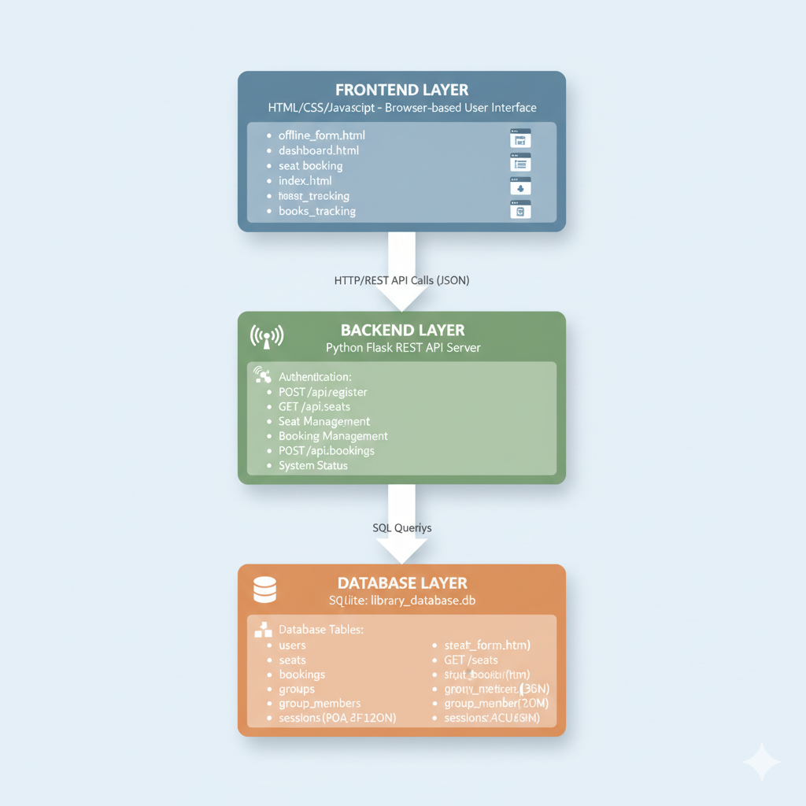

Application Workflow

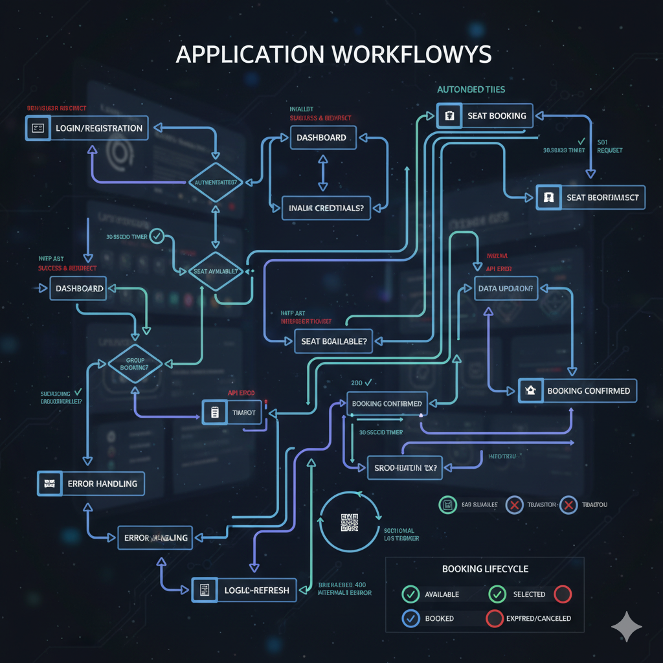

File Structure
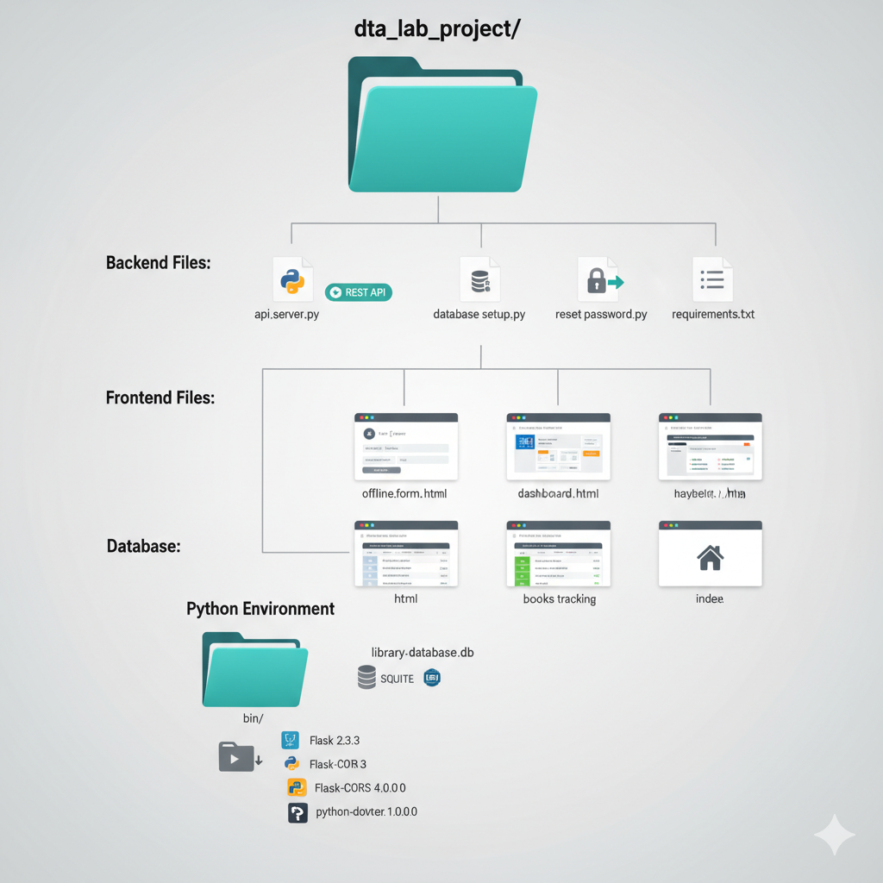

References

- G. Yang, X. Chang, Z. Wang, and M. Yang, ”A serial dual-channel library occu-pancy detection system based on Faster RCNN,” arXiv:2306.16080v2 [cs.CV], 2024.

- X. Li et al., ”Smart Library: A CNN-Based Seat Occupancy Detection System,” in Proc. IEEE Int. Conf. on Automation and Computing, 2021.

- Y. Wang and J. Zhang, ”Real-Time Library Seat Monitoring Using Deep Learn-ing,” Journal of Ambient Intelligence and Humanized Computing, vol. 12, 2021.

4 ”SeeAt: A System for Visualizing and Analyzing Occupancy Trends in Li-brary Spaces,” [Online]. Available: https://www.ischool.berkeley.edu/sites/de-fault/files/sproject_attachments/seeat

- M. Papakonstantinou et al., ”Occupancy Detection via iBeacon on Android Devices,” in Proc. of the 16th International Conference on Mobile and Ubiq-uitous Systems: Computing, Networking and Services, 2019.

- B. Friedman and H. Nissenbaum, ”Bias in Computer Systems,” ACM Transac-tions on Information Systems, vol. 14, no. 3, 1996.

- H. Nissenbaum, ”Privacy as Contextual Integrity,” Washington Law Review, vol. 79, no. 1, 2004.

